VENKITTU SRINIVASAN
  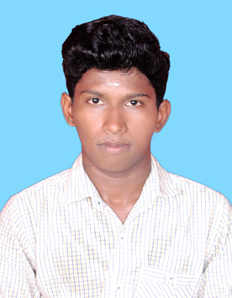
  MOBILE | +91-8940317720
  MAIL | venkatjara30@gmail.com
  GIT HUB ID | https://github.com/VenkittuS

CAREER OBJECTIVES
To work in a healthy, innovative and challenging environment extracting the best out of me, which is conducive to learn and grow at professional as well as personal level thereby directing my future endeavors as an asset to the organization.

PERSONAL SKILL
Comprehensive problem solving abilities, ability to deal with people diplomatically, willingness to learn, team facilitator

COMPUTER PROFICIENCY
Operating System | Windows8,7,Xp
Language | JAVA
Web Technologies | HTML, CSS
Packages | MS-Office.

EDUCATIONAL STATUS
COURSE | INSTITUTION | BOARD/UNIVERSITY | PERCENTAGE | YEAR OF PASSING
B.E(CSE) | Dr.Navalar Nedunchezhiyan College of Engineering,  Tholudhur | Anna university | 6.38(CGPA) | 2016
HSC | Aruna Higher Secondary school, Eraiyur | State board | 65 | 2012
SSLC | Aruna Higher Secondary school, Eraiyur | State board | 84 | 2010

FIELD OF INTEREST
- Web designing

PROJECT:
REGION BASED REGISTRATION USING K-MEANS CLUSTERING ALGORITHM FOR VIDEO INPAINTING

SOFTWARE | MAT LAB
DESCRIPTION | The Project is mainly aimed to video background reconstruction

STRENGTH
- Self-Confidence
- Honesty
- Quick learner

CO-CURRICULAR ACTIVITIES
Attended one day workshop on “ANDROID” in our college
- I am pursuing “payilagam software training institute”(CORE JAVA,HTML,CSS)

LEADERSHIP SKILLS
- Being Representative for one year from”2013-2014”- Academic year in my college

HOBBY
- I like to play cricket.
- Watching news
PERSONAL PROFILE
GENDER | MALE
MARITIAL STATUS | SINGLE
FATHER’S NAME | N SRINIVASAN
ADDRESS | 56/2,middle street,  Eraiyur (po),  Tittagudi(Tk),  Cuddalore(Dt)-606111
DOB | 30-NOV-1994

DECLARATION
I here declare that the information furnished above is true to the best of my knowledge.

DATE:
PLACE: | VENKITTU S

